2008 summer course, C-language Homework 2

Exercise 1 (2’s complement): we have shown that signed integer of 2’s complement under size = 4-bits ranges from -8 to 7, the complete mapping between decimal and 2’s complement is
decimal | 2’s complement (binary) | decimal | 2’s complement (binary)
0 | 0 0 0 0 | -8 | 1 0 0 0
1 | 0 0 0 1 | -7 | 1 0 0 1
2 | 0 0 1 0 | -6 | 1 0 1 0
3 | 0 0 1 1 | -5 | 1 0 1 1
4 | 0 1 0 0 | -4 | 1 1 0 0
5 | 0 1 0 1 | -3 | 1 1 0 1
6 | 0 1 1 0 | -2 | 1 1 1 0
7 | 0 1 1 1 | -1 | 1 1 1 1
Now answer the following questions
- 2’s complement representation of 0 is unique
- for general , signed integer of 2’s complement ranges from to .
- Suppose integer is of size 4-bits, a number has 2’s complement representation , how can we know its decimal value? (Hint: do 2’s complement for again)

Exercise 2: read page 153~155 in textbook to know conversion specification, we usually use
character | Argument type ; printed as
d | int; decimal number
c | int ; single character
s | char * ; print characters from the string until a ‘\0’
f | double, fixed representation
e,E | double, scientific representation

Exercise 3 (limit of integer type): use Visual Studio to create a project, named as limit_test, and write codes to test size and limits of data type in Table 1. You can refer codes in Error: Reference source not found. Explain how do you why the minimum value you fill-in is actual minimum.
Table 1: fill-in the blanks by writing code in your computer, note that data type is implementation defined, just take data in MSDN library as reference, you must confirm them in your computer.
Case 1: your PC
CPU =
OS (operating system) =
Compiler =
Type | Bytes | Minimum value | Maximum value
(signed) short (int)
(signed) int
(signed) long (int)
unsigned short
unsigned int
unsigned long
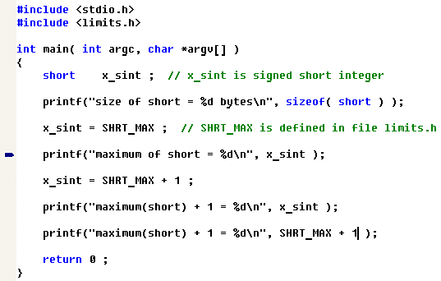
Figure 1: codes to test size and limits of data type “short”.
Case 2: workstation
CPU =
OS (operating system) =
Compiler =
Type | Bytes | Minimum value | Maximum value
(signed) short (int)
(signed) int
(signed) long (int)
unsigned short
unsigned int
unsigned long

Exercise 4 (escape sequence): read section 2.3 (page 37~38) to know escape sequence and use Visual Studio to create a project, named as char_test, and write codes to find out integral value of escape sequence, like Error: Reference source not found.
- What is execution result, are the results consistent with ASCII table?
- If we change NUM_ESCAPE_CHAR = 6 and sweep 12 elements in array “word”, like Error: Reference source not found. Compare these results with results of (1), what’s the difference? Can you find out potential bug of this code?
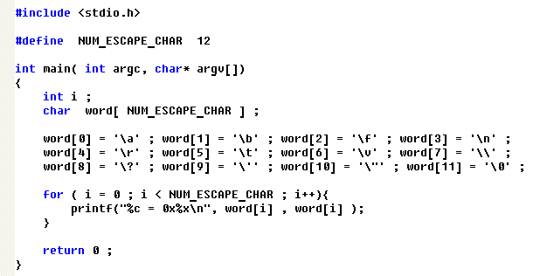
Figure 2: display character and hexadecimal value of escape sequence.

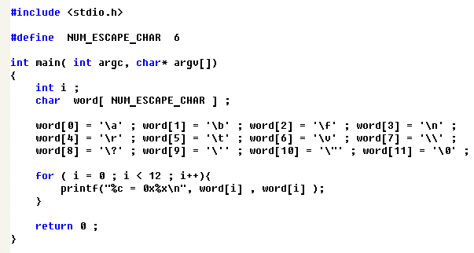
Figure 3: array size is declared too small to contains all escape sequences.

Exercise 5 (string constant): use Visual Studio to create a project, named as string_const, and write codes to find relationship between string constant and character array, like
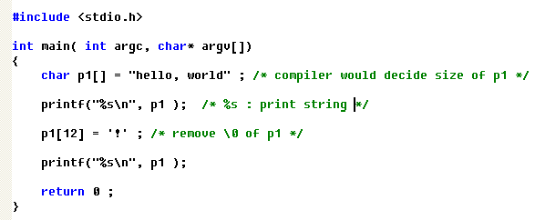
Figure 4: string constant versus character array.
- why second “printf” does not print “hello, world!”, could you explain this?
- May you modify second “printf” such that you can print “hello, world!”? Hint: you can print character by character if you know size of the string.
- Why we need string terminator ‘\0’ ?
- Read A2.6 in page 194

Exercise 6 (string concatenation): use Visual Studio to create a project, named as strcat_test, and search for “strcat” in MSDN library, find theme “strcat,wcscat” as following figure, copy the source code in that theme, see Error: Reference source not found, verify the result.
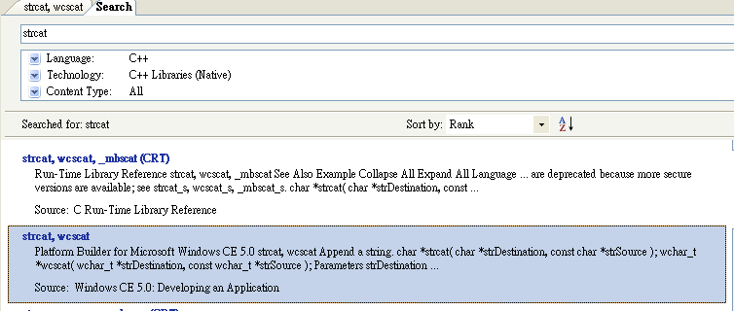
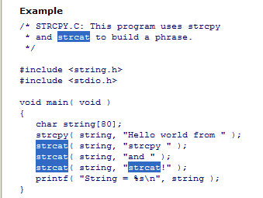
Figure 5: example code in theme “strcat,wcscat”
How about if we modify statement “char string[80];” to “char string[10];”? Can you explain the execution result?

Exercise 7 (convert single precision binary format to decimal value)
convert following binary representation into normalized decimal value
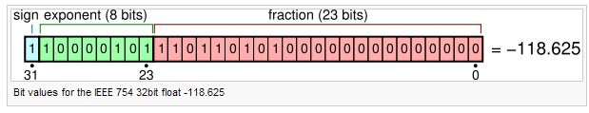

Exercise 8 (transformation between string and integral/floating)
In the course, we draw a picture to show transformation between string and integral/floating as Error: Reference source not found, we know that convert string to integral/floating is easy since standard C support library function atoi, atof, atol to do this.
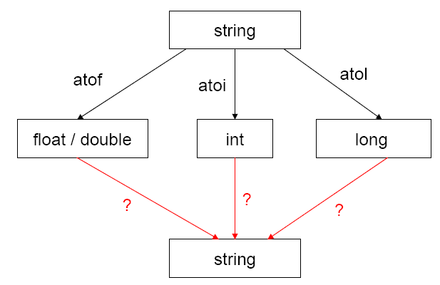
Figure 6: convert string to integral/floating is easy by standard library.
- use MSDN library to search for atoi, atof and atol, and test example shown in MSDN library, what do you learn in these examples.
- Can you implement the converse way, that is, convert integral/floating to a string?

Exercise 9 (potential bug of equality operator): Test the code in Error: Reference source not found, C-language accept such coding style, try to invert “x = 1” to “1 = x”, what is compilation error in g++ and icpc?
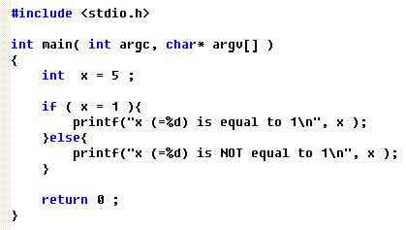
Figure 7: x == 1 or 1 == x, which one is better

Exercise 10 (bitwise operator): consider 8-bit operation,
(1) and what is , and ? write a program to demonstrate this and interpret the result.
(2) Can you use AND operation to implement modulo operation, for example ?

Exercise 11 (shift operator): in the course, we define type of a_left_shift_1 (which is ) as int, why? Can we define it as char as you see in Error: Reference source not found, what’s the difference?
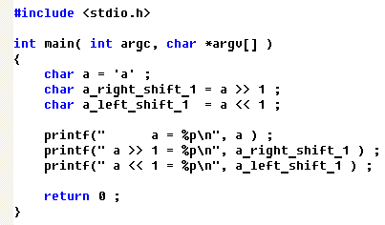
Figure 8: define a_left_shift_1 as char.

Exercise 12 (shift operator versus multiplication): Can you use shift operator to implement multiplication or division on an integer number? Write program to test your idea.

Exercise 13 (type conversion): try all combination of rules of type conversion in textbook, do you thank that explicitly casting done by program himself is a good habit?

