A Universal Microarray Biochip for detection of
SARS and anthrax
Chih-Wei Lin D937708(contribution 100%)

In May, 20, 2006, our country has just attacked by a series of bioweapons fired from Mainland China. Our people fear for their safety and heath. It’s really a war time. Our brave President Liu tries his best and proclaims a research request to save his people.

“We need compact diagnostics systems to provide triage to screen large numbers of people against the outbreaks of diseases that are bogging down our local healthcare systems”, President Liu said.

According to our collect information, we are attacked by two type bio-weapons, one is SARS and another is anthrax.
SARS
Severe Acute Respiratory Syndrome (SARS) is caused by coronavirus. Thus, we called SARS-CoV. In 2003, SARS was first detected in Asia. Few months letter, SARS spread to North America, South America and Europe. During the 2003, 8,098 people worldwide get SARS-CoV, and 774 were died. Generally, when you get SARS, your body temperature will be higher than 38.0°C. Other symptoms include headache, discomfort, mild respiratory, diarrhea, dry cough, pneumonia and body aches.
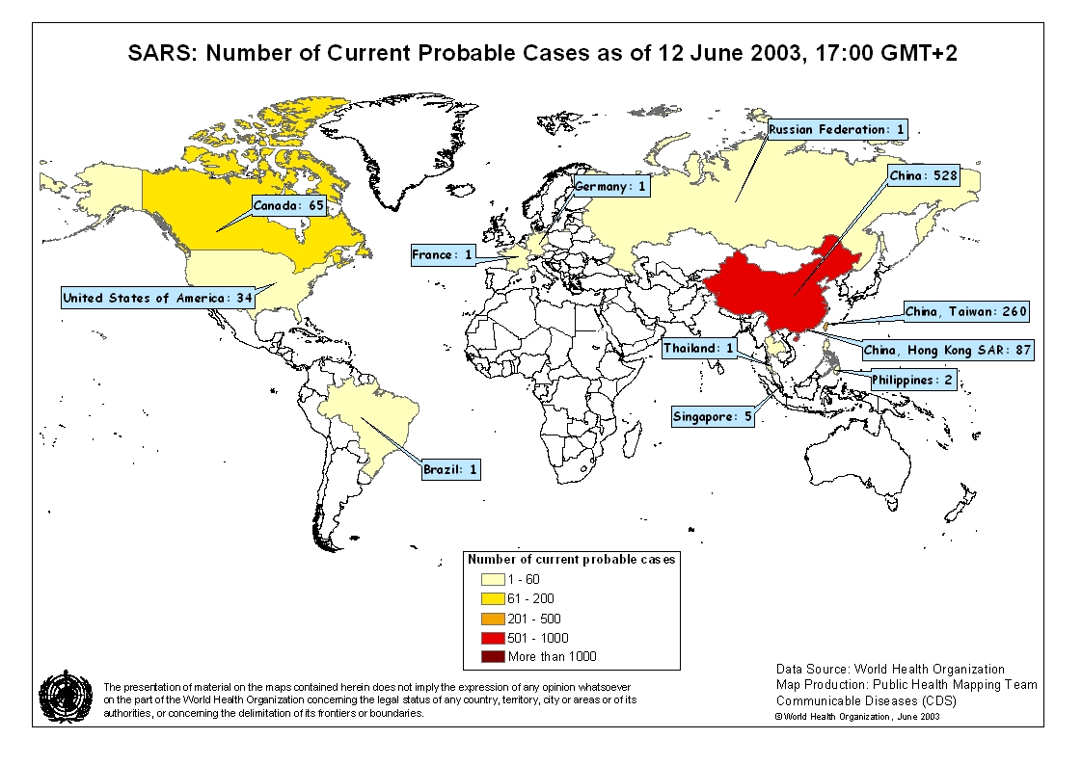
Figure 1. SARS-CoV spread diagram
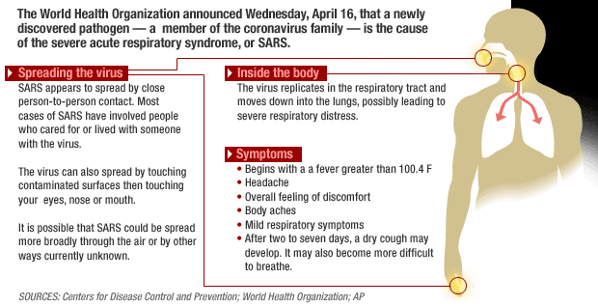
Figure 2. Symptoms of SARS
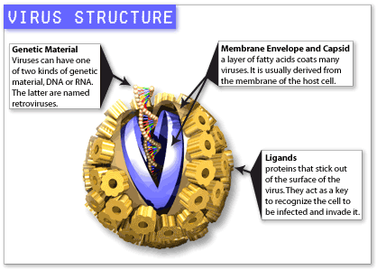
Figure 3. Virus structure of SARS-CoV
Anthrax
Anthrax is caused by the spore-forming bacterium, called Bacillus anthracis. Anthrax is a disease of animal (cattle, sheep, camels, and other herbivores) and humans. Anthrax is often detected in animals in agricultural regions; include South and Central America, Southern and Eastern Europe, Asia, Africa, the Caribbean, and the Middle East. Anthrax can be infected in three ways: skin, inhalation, and gastrointestinal. Usually, B. anthracis spores can live for many years in proper soil, so it is easy to infect when you exposed to dead infected animals caused by anthrax or eat undercooked meat from infected animals.
Symptoms of anthrax depend on how the disease was contracted:
- Skin: skin infection will raise an itchy bump, usually 1-3 cm in diameter, and with a dying area in the bump center. Then, lymph in the nearby area will swell. About 20% will result in death.
- Air: In the beginning, symptoms may like a common cold. Several days later, the symptoms will be severe breathing problems.
- Intestinal: intestinal infection will be nausea, loss of appetite, vomiting, fever are followed by abdominal pain, vomiting blood, and severe diarrhea, and which will result in death in 25% to 60%.
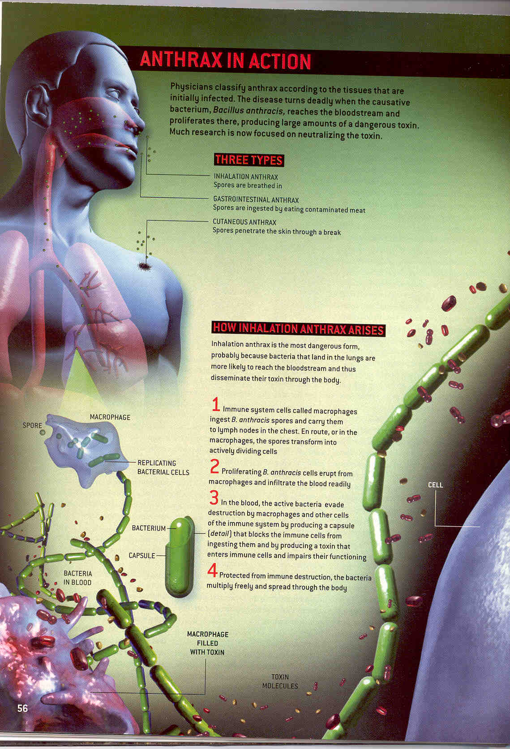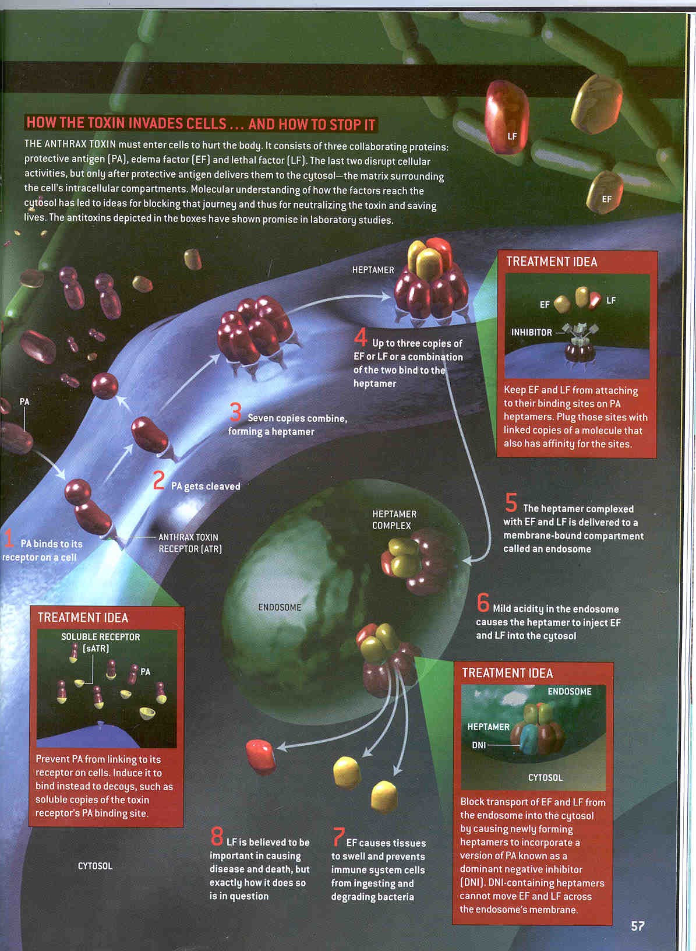
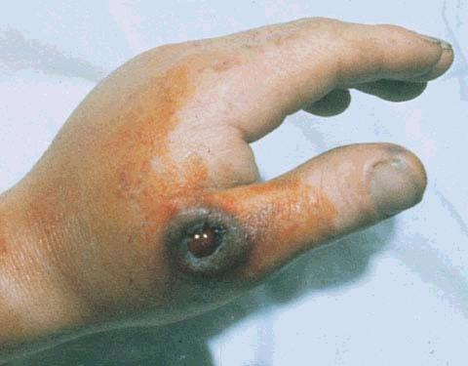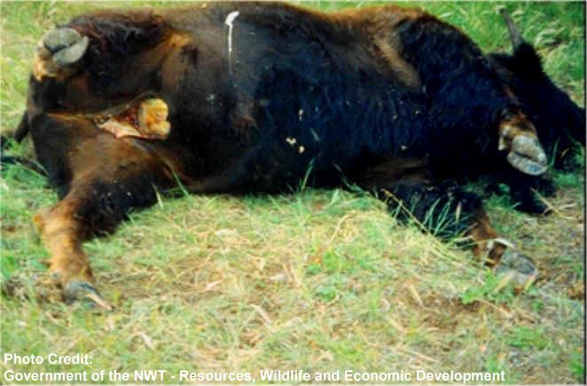
Figure 4. Symptoms of anthrax
PMC（Fictitious Company）
Power MEMS Company (PMC) is a world-leading MEMS group, located in Hsinchu, and cooperates with many IC companies, such as TSMC and UMC, for a long time. In order to promote the efficiency of the products, we have set up the world-class laboratory and employ the best engineer. Now, we can meet customer's demands in the shortest time.
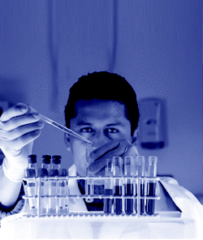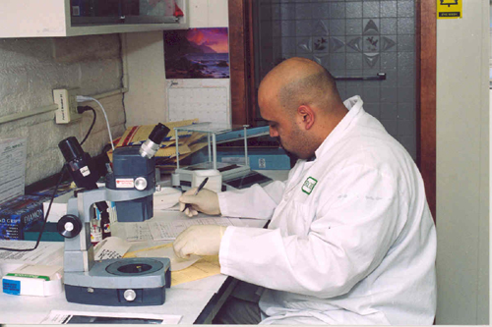
Figure 5. Powerful researchers

Now, our country is facing the great danger and disaster. Anyone should do their best to help our country to spend this difficulty. For this reason, within the shortest time, we combine two key technologies, real time polymerase chain reaction and bio-bar code DNA detection technique, to design such a power chip to check whether the patient is infected the SARS or anthrax. Its name is “Universal Microarray Biochip-L1”.
About RT PCR and Bio-bar code DNA detection technique
Real Time Polymerase Chain Reaction (RT PCR) is a technique to monitor the progress of a PCR reaction in real time. By this method, a relatively small amount of DNA, cDNA or RNA can be quantified. By the further researches, it was found that the six nucleotide positions (nt9404, nt9479, nt19838, nt21721, nt22222, and nt27827) have an important relationship to detect 40 SARS-CoV genome sequences and two SARS-like coronavirus genome sequences. Bio-bar code DNA detection technique is invented in 2004. It is able to detect 10 strands of target DNA in a 30 microlitre sample. Combine the two powerful technologies in the microarray, we developed the Universal Microarray Biochip-L1 Biochip. Using such a biochip, we can diagnosable patients are infected with the SARS-CoV or anthrax in the same time.
Figure 6. Bio-bar code DNA detection technique diagram

Figure 7. Universal Microarray Biochip-L1 detection process diagram
Conclusions
Every committee member, our people are being threatened by virus at present. PME Company has world-class equipment and researchers, new age product “Universal Microarray Biochip-L1” can receive the most correct detect result within shortest time. It’s war time, we need your support, enable us to help our compatriot as soon as possible.

Your support can let us help more people.

