Biological Structure: Diatom, Geckos and Insect Feet
Chih-Wei Lin D937708 (contribution 100%)

Example 1: Diatoms
Diatoms are either unicellular or colonial. We can find diatoms all waters of the Earth. The characteristic of diatoms is that the cell wall is made by hydrated silicon-dioxide and feature sizes less than 5 nm. This size is too small; I don’t know which MEMS fabrication process can form this size.

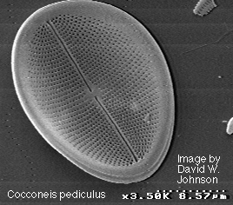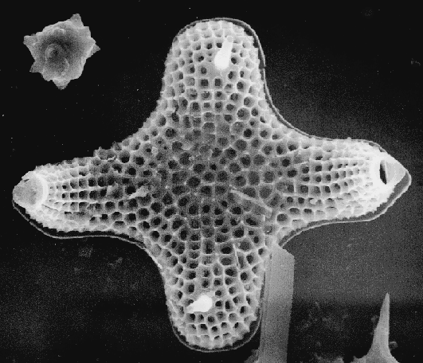
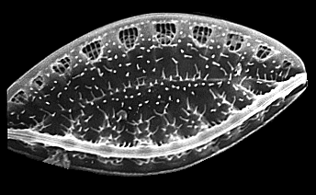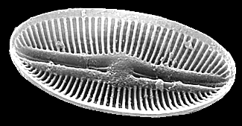
Fig. 2-1 Different Diatoms microstructure

Example 2: Wall-climbing hairs and attached pad
Geckos are often seen in our house, which have special adhesion ability to climb on the wall. For the same reason, Tettigonia viridissima (an insect captured in Germany) owns attachment pad. These microscopic structures, made by “nanotechnology”, on their feet are created to increase wall-climbing or attached ability. About the wall-climbing hair and attached pad structures, I think this structure can be made by MEMS fabrication processes, but may not be have high density.
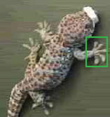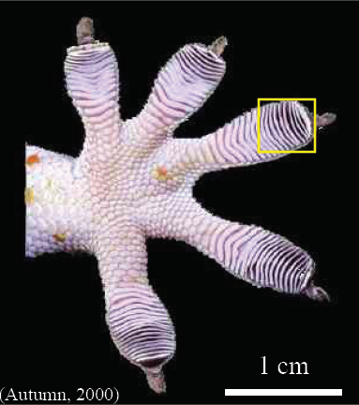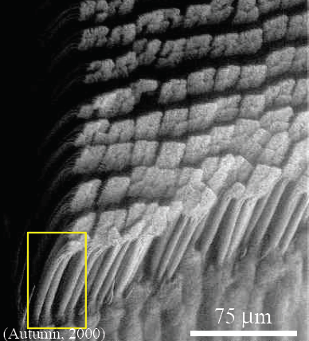
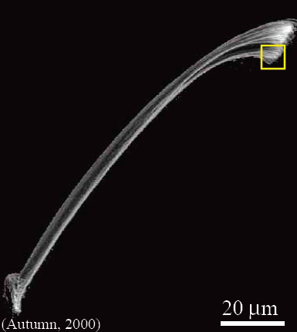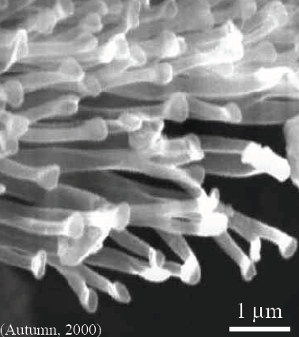
Fig. 2-1 The wall climbing hairs of Geckos
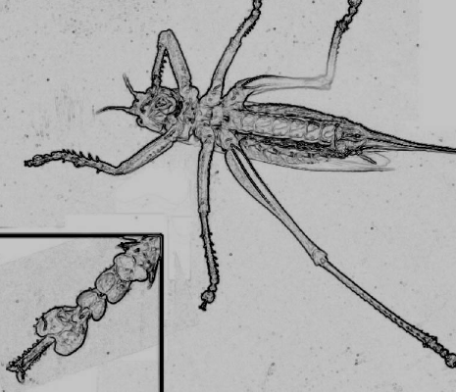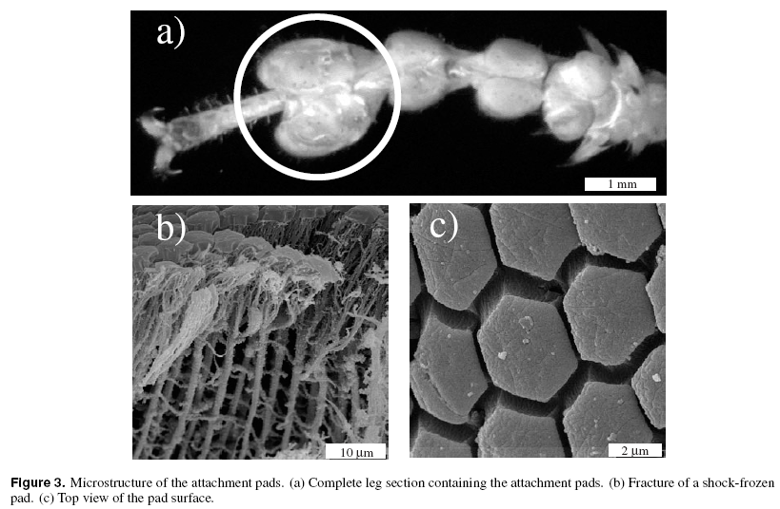
Fig. 2-2 The attached pad of Tettigonia viridissima (an insect captured in Germany)

Example 3: Insect walking-feet
This orange question is “the biological micromachining examples can be contrasted with micromachining”, but in this example, the micro-machined structure is already made. This robust 3D silicon structures are made by polysilicon micro-fabricated hinge technique, and use bimetallic effect (electrostatic displacement) to bend the out-of-plan structure. The key structure material of micro-joint is a highly flexible material. By the fabrication processes introduced before, the micro-conveyer or micro walking robot, look like scolopendrids, can be made.
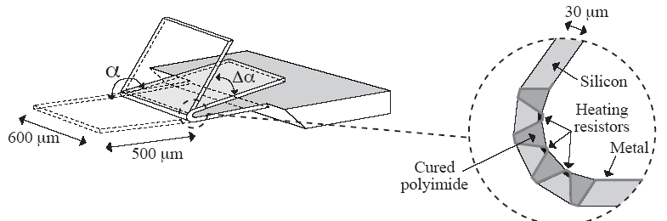
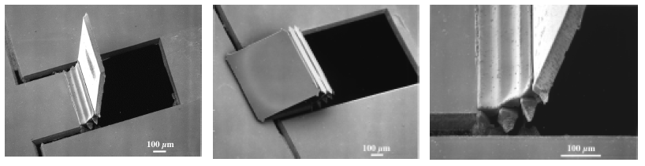
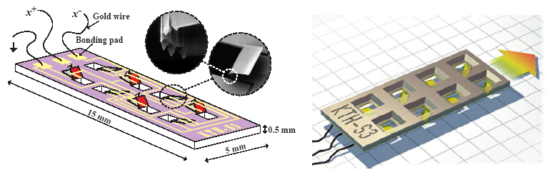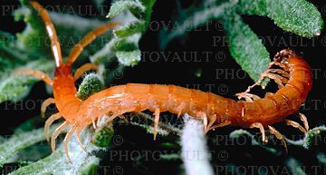
Fig. 2-3 Micro walking robot and scolopendrid
Reference:
- (http://www.eecs.berkeley.edu/~holtz/diatoms/) 2004/10/12
- T. Kenny, “MEMS Devices for Force Sensing in Biology”, Stanford University ME.
- M. Scherge, S. N. Gorb, “Using biological principles to design MEMS”, J. Micromech. Micoreng, Vol. 10, pp. 359-364, 2000.
- T. Ebefors, U. M. Johan. K. Edvard, G. Stemme, “ 3D micromachined devices based on Polyimide Joint technology”, Conference on Devices and Process Technologies for MEMS and Microelectronics SPIE, Vol. 3892, pp. 118-132, 1999.

