Micromachined Gyroscopes
Chih-Wei Lin D937708 (contribution 100%)

In question 1, I choice the topic “Gyroscope” to discuss the advantages of “Micromachined Gyroscope”. The definition of gyroscope by NASA is:

“A rotating wheel, mounted in a ring or rings, for illustrating the dynamics of rotating bodies, the composition of rotations, etc. It can also be a form of the above apparatus, mounted so delicately as to render visible the rotation of the earth, through the tendency of the rotating wheel to preserve a constant plane of rotation, independently of the earth's motion.”

The micro gyroscopes work following the same principles as “Foucault Pendulum”, which is used to measure the angular rotation of the Earth and made by Jean B. L. Foucault (1819～1868). A suspended mass is allowed to sense oscillation and rotation induced by “Coriolis force”. By detect the position and velocity of the mass, the precision angle can be measured, which is proportional to the angle of rotation. Now, the common drive and sensitive mechanisms in micro gyroscope are electro-statically driven and capacity sensitive.
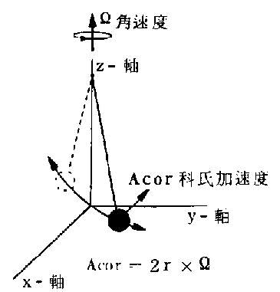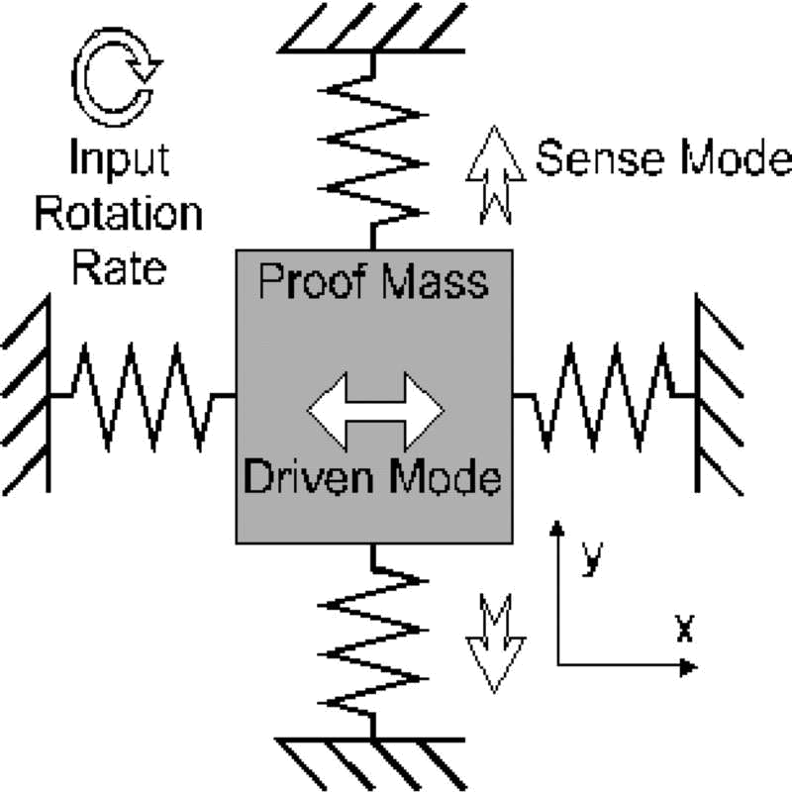
Fig. 1-1 Foucault pendulum

There are two types for micro gyroscope: non-mechanical (optical) and mechanical, but here I focus on mechanical gyroscope. Micro gyroscopes use vibration structure to sense the rotation rate by sensing the Coriolis acceleration in a vibration proof-mass system, because it is difficult to made a rotating wheel like traditional gyroscope in MEMS fabrication processes. By different vibration structure, the vibratory gyroscope can be divided into: vibrating prismatic beam, tuning fork, dual accelerometer, resonant ring and vibrating shell.
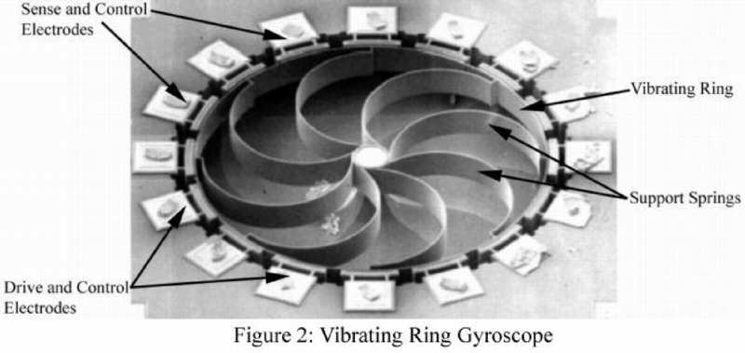
Fig. 1-2 Resonant ring gyroscope

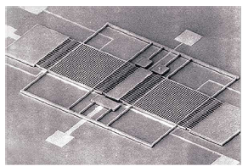
Fig. 1-3 Draper tuning fork gyroscope

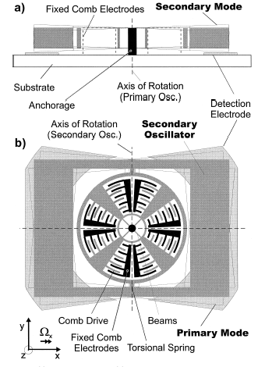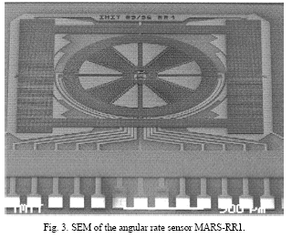
Fig. 1-4 Micromachined Angular Rate Sensor with two rotary oscillation modes (MARS-RR)

The commercial applications of gyroscope are ride stabilization system, traction control system, navigation, airplane-control, platform stabilization, and video camera. The advantages of gyroscope made by micro-machining are:
- Multi-function in one chip: during limited space, we can combine more sensors in one chip, such as pressure and temperature sensors.
- Mass production
- Low production cost down and power consumption
- High sensitivity

The scale laws for a key figure-of-merit for micro gyroscope are
Usually, Coriolis Effect can be described by this equation.
$$\begin{aligned}F_{c}=2mv×Ω \\ m:\text{mass} \\ v:\text{velocity} \\ Ω:\text{angular} \text{velocity}\end{aligned}$$
According [7], the scale factor of mass is “L³”, and “L” for velocity. Thus, the scale factor of micro gyroscope is L⁵.

Reference:
- http://spaceflight.nasa.gov/history/shuttle-mir/references/glossaries/science/sc-gloss-g_m.htm
- Surface Micromachined Gyroscope http://www.mems.eee.metu.edu.tr/projects/gyroscope2.htm
- A. Duwel, J. Gorman, M. Weinstein, J. Borenstein, P. Ward, “Experimental study of thermoelastic damping in MEMS gyros”, Sensors and Actuators A, Vol. 103, pp.70-75, 2003.
- C. Painter, A. Shkel, “Structural and thermal analysis of a MEMS angular gyroscope”, SPIE's 8th annual symposium on Smart Structures and Materials, Newport Beach, CA, March 2001.
- W. Geiger, B. Folkmer, J. Merz, H. Sandaier, W. Lang , “A new silicon rate gyroscope”, Sensors and Actuators, Vol. 73, pp. 45-51, 1999.
- 徐玉紋, “振動式微加工陀螺儀簡介”, 機械月刊, 第二十一卷, 第十一期.
- 行政院國家科學委員會精密機械發展中心, “微機電系統技術與應用”, 全華出版社, 民國92年.

