Abstract-- In this paper, I present the artificial hair and flow sensors in biomimetic micro-sensor field. Different fabrication process, structures, and sensing mechanisms of artificial hairs and flow sensors are introduced.
Biomimetic Micro Sensors:
Artificial Hair and Flow Sensors
Chih-Wei Lin D937708
NTHU PME Engineering Design Lab.

INTRODUCTION
The word “Biomimetic” means “Imitating, copying, or learning from nature”. MEMS (Micro Electromechanical Systems) have been developed for a long time. Many MEMS sensors base on the natural phenomena and this is so-called biomimetic micro sensors.
Many insect species use hair cells to recognize the surrounding airflow, and fish use lateral line hair cells to sense the water flow around his body (Fig.1). Thus, the focus of this paper is: artificial hair cell and flow sensor.
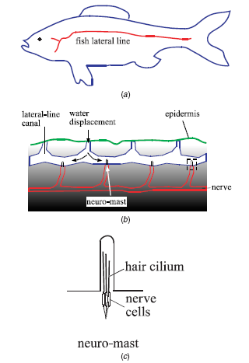
Fig. 1 Schematic diagram of fish lateral line systems [1]

Procedure for Paper Submission

Literature review
Li [2] successfully used bulk-micromachining fabrication process and polymethylsiloxane (PDMS) elastic polymer material to fabricate the modular artificial hair cell (AHC). Chen [3] developed the out-of-plane micromachined hot-wire air flow sensor by combining surface micromachining and three-dimensional assembly. The anemometer sensing filament is made of metal, which can provide great sensitivity. The process during the fabrication is lower than 250℃. Fan [1] combined bulk micromachining and plastic deformation magnetic assembly (PDMA) process to develop an individual micromachined artificial lateral line flow sensor. Baar [4] integrated high-density arrays of artificial hairs with capacitive read-out.

Artificial hair structure
In Fig.2, the artificial hair cell consists of a cantilever beam, a polysilicon piezoresistor and a Whetstone bridge circuit. The AHC handle is made from polymethylsiloxane (PDMS), which will be explained later. In Fig.3, the sensor structure types are with spiral spring suspension and with double-gimbal suspension base on the capacitive sensing mechanism. Thus, the main features of the artificial hairs are: (1) hairs should be stiff and made from a low-density material. (2) weak torsional springs are needed at the base of the hairs. (3) The system should be heavily damped.
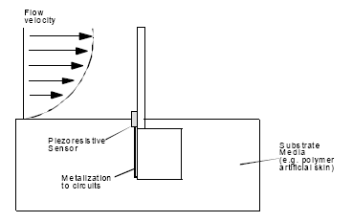
Fig.2 Schematic diagram of an AHC as a flow sensor [2]
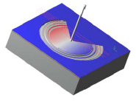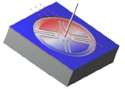
Fig.3 Sensor structure with spiral spring and double-gimbal[4]

Principle of Sensing
Commercial flow sensors are usually based on two sensing principles: (1) Hot Wire Anemometry (HWA): when flow passes through the heated element, the probe temperature will reduce; (2) Laser-Doppler Velocimetry (LDV): using Doppler frequency-shift effect to detect the flow speed, but this method has poor resolution, and lower frequency response.
Besides HWA and LDV sensing mechanism, Piezoresistive, Capacitive, and Piezoelectric sensing mechanisms are often used in many micro-sensors (Table 1). In literature [2] and [1], the AHC uses Piezoresistive sensing mechanism (Fig. 5), capacitive in Fig.6, and hot-wires in Fig. 7. By different sensing mechanisms, the sensor structure must be different to contain resistors, capacitor electrodes, or heated element.

Table 1 Comparison of MEMS sensing properties[5]
 | Parameter sensed | Complex system
Piezoresistive | Strain | *
Capacitive | Displacement | **
Piezoelectric | Force | **

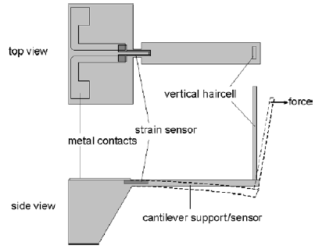
Fig.5 Sensing the bending of the vertical cilium using the strain sensor located at the base of the horizontal cantilever[1]

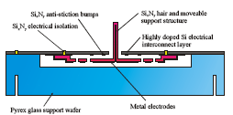
Fig.6 Sensing the drag force by capacitive sensing method [4]

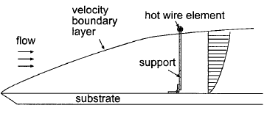
Fig.7 Schematic diagram of an out-of-plane, surface micro-machined hot wire anemometry[3]

Fabrication of artificial hairs
Usually, the fabrication process of artificial hairs can be divided into two types, one is hairs fabricated in the wafer plane (Fig.8), and another type is hairs fabricated perpendicular to the wafer plane. The surface micromachining fabrication is most easy, and the drawbacks are:
(1) Cannot be combined into high-density arrays
(2) Artificial hairs will be not symmetrical, and just only support one direction sensitive.
Zou [6] proposed plastic deformation magnetic assembly (PDMA) method to erect the hairs out of wafer plan (Fig. 9), which uses the interaction between pieces of magnetic material electroplated under an applied magnetic field. This magnetic field affect will induce a torque to bend the ductile material such as Gold or Al out of plane. The structure maybe plastically deformed when the bending force is large enough. Fig. 10 indicated the SEM micrograph of a single artificial hair sensor by PDMA.
In 2003, Baar use bulk micromachining of hair array, which are fabricated in the wafer instead of on the wafer surface (Fig. 11-12).
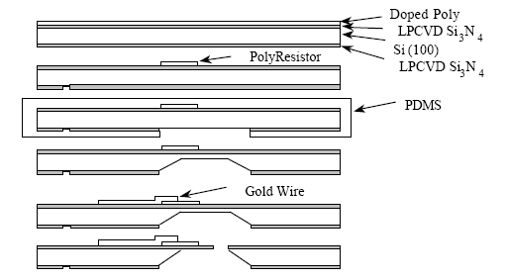
Fig. 8 Schematic diagram of the developed fabrication process for the in-plan artificial hair cell [2]

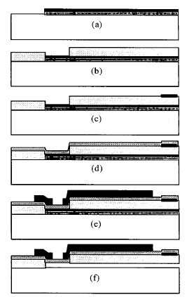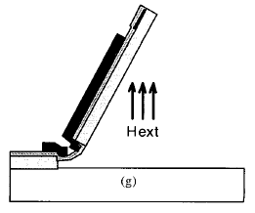
Fig. 9 The PDMA fabrication process[3]

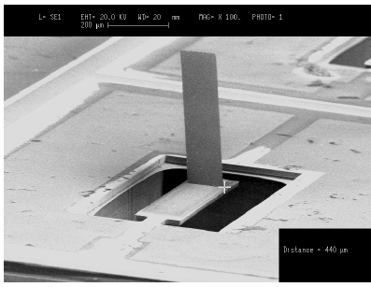
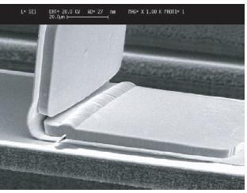
Fig.10 An SEM micrograph of a single artificial hair sensor by PDMA. [1]
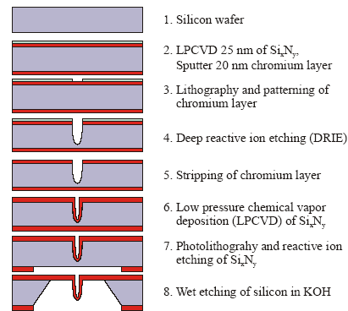
Fig. 11 Process sequence used for bulk micromachining of artificial hairs[4]

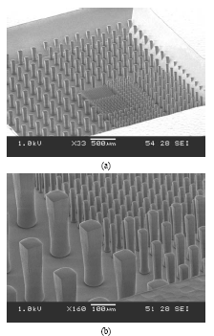
Fig. 12 Array of fabricated hairs[4]

Conclusion
In this homework assignment, I choice the topic “ Biomimetic Micro/ Nonoscale Sensors and Actuators” to search related papers. After surveying papers, I focus my homework field to “Artificial Hairs and Flow sensors” just because they have many similar structure and functions. I did not decide my research field, maybe this is a good choice.
References
[1] Z. Fan, J. Chen, J. Zou, D. Bullen, C. Liu, and F. Delcomyn, "Design and fabrication of artificial lateral line flow sensors," Journal of Micromechanics and Microengineering, vol. 12, pp. 655-661, 2002.
[2] J. Li, J. Chen, and C. Liu, "Micromachined Biomimetic Sensor Using Modular Artificial Hair Cells," in Nano Space 2000. Houston, 2000.
[3] J. Chen, J. Zou, and C. Liu, "A surface micromachined, out-of-plane anemometer," in Micro Electro Mechanical Systems, 2002. The Fifteenth IEEE International Conference, 2002.
[4] J. J. Baar, M. Dijkstra, R. J. Wiegerink, T. S. J. Lammerink, and G. J. M. Krijnen, "Fabrication of arrays of artificial hairs for complex flow pattern recognition," in IEEE Sensors Conference. Toronto, 2003.
[5] G. T. A. Kovacs, Micromachined Transducers Sourcebook: WCB/McGraw-Hill, 1998.
[6] J. Zou, J. Chen and C. Liu, "Plastic Deformation Magnetic Assembly (PDMA) of Out-of-Plane Microstructures: Technology and Application," IEEE/ASME Journal of MEMS, vol. 10, pp. 302-309, 2001.

 

